**VIETNAM NATIONAL UNIVERSITY HO CHI MINH CTIY**

**UNIVERSITY OF INFORMATION TECHNOLOGY**

**ADVANCED PROGRAM IN INFORMATION SYSTEMS**

**LE SANH PHUC - PHAM TANG TUNG**

**ADVERTISMENT SYSTEM IN MOBILE PLATFORM**

**WITH AUGMENTED REALITY**

**BACHELOR OF ENGINEERING IN INFORMATION SYSTEMS**

**HO CHI MINH CITY, 2015**

**VIETNAM NATIONAL UNIVERSITY HO CHI MINH CTIY**

**UNIVERSITY OF INFORMATION TECHNOLOGY**

**ADVANCED PROGRAM IN INFORMATION SYSTEMS**

**LE SANH PHUC 11520288**

**PHAM TANG TUNG 11520462**

**ADVERTISMENT SYSTEM IN MOBILE PLATFORM**

**WITH AUGMENTED REALITY**

**BACHELOR OF ENGINEERING IN INFORMATION SYSTEMS**

**THESIS ADVISOR**

**ASSOC. PROF. DR. TRAN MINH TRIET – MSC. LUONG VI MINH**

**HO CHI MINH CITY, 2015**

# ASSESSMENT ADVISOR

………………………………………………………………………………………………………………………………………………………………………………………………………………………………………………………………………………………………………………………………………………………………………………………………………………………………………………………………………………………………………………………………………………………………………………………………………………………………………………………………………………………………………………………………………………………………………………………………………………………………………………………………………………………………………………………………………………………………………………………………………………………………………………………………………………………………………………………………………………………………………………………………………………………………………………………………………………………………………………………………………………………………………………………………………………………………………………………………………………………………………………………………………………………………………………………………………………………………………………………………………………………………………………………………………………………………………………………………………………………………………………………………………………………………………………………………………………………………………………………………………………………………………………………………………………………………………………………………………………………………………………………………………………………………………………………………………………………………………………………………………………………………………………………………………………………………………………………………………………………………………………………………………………………………………………………………………………………………………………………………………………………………………………………………………………………………………………………………………………………………………………………………………………………………………………………………………………………………………………………………………………………………………………………………………………………………………………………………………………………………………………………………………………………………………………………………………………………………

# ASSESSMENT COMMITEE

………………………………………………………………………………………………………………………………………………………………………………………………………………………………………………………………………………………………………………………………………………………………………………………………………………………………………………………………………………………………………………………………………………………………………………………………………………………………………………………………………………………………………………………………………………………………………………………………………………………………………………………………………………………………………………………………………………………………………………………………………………………………………………………………………………………………………………………………………………………………………………………………………………………………………………………………………………………………………………………………………………………………………………………………………………………………………………………………………………………………………………………………………………………………………………………………………………………………………………………………………………………………………………………………………………………………………………………………………………………………………………………………………………………………………………………………………………………………………………………………………………………………………………………………………………………………………………………………………………………………………………………………………………………………………………………………………………………………………………………………………………………………………………………………………………………………………………………………………………………………………………………………………………………………………………………………………………………………………………………………………………………………………………………………………………………………………………………………………………………………………………………………………………………………………………………………………………………………………………………………………………………………………………………………………………………………………………………………………………………………………………………………………………………………………………………………………………………………

ACKNOWLEDGEMENTS

We would like to express our gratitude to advisors, Associate Professor PhD. Tran Minh Triet and MSc. Luong Vi Minh who suggest, instruct and encourage us during the time we do thesis.

We would like to express my thankful to Mr. Le Trung Nghia – an elder brother from class Advanced Program in Computer Science 2008 in Ho Chi Minh University of Natual Science for their advices in researching Vuforia framework.

We appreciate the charity of JetBrain and Microsoft corporation. They have supply the all free professional, utimate software licenses to students that help us a lot of things not only in the thesis, but also in our study in university. Somee and GitHub also recommends free hosting, server to us.

We would like to express my thankful to the staffs in Faculty of Information Systems of University of Information Technology who emit the passion to us as well as equipt us enough basic kwnoledge in the recent year.

We should say thank you to our family for providing us the best conditions to study in Advanced Education Program and finish this graduation thesis.

Although we have try effort to finish this thesis in suitable range and our best abilities; certainly it can not avoid the disadvantages and errors, we respecfully wait for sympathy and feedbacks of our Lecturers and friends. We sincerely say thank you.

Winter 2015,

Le Sanh Phuc – Pham Tang Tung – Student of CTTT2011

LIST OF FIGURES

F: Tên hình 1 3

LIST OF TABLES

Bảng 1.1: Tên bảng 1 3

Bảng 2.1: Tên bảng 1 4

LIST OF ABBREVIATIONS

ABSTRACT

Advertisement is the fundamental method of marketing. The target of advertisement is to provide information and attract customer to pay attention about corporations, products, or services of suppliers. By the progressive development of economy, advertisement plays important and indispensable role. Moreover, mobile market grows more and more with the provident of the diversity of every classes, every ages of customers; especially smartphone and tablets. Therefore, the advertisement transfers gradually from the tradition ways like newspapers, magazines, poster… to TV, radio and mobile advertisement now.

Customers have a lot of activities with diverse points to accumulate points, promotion programs is concreted, and difficult to manage. By the above reason, there is potential solution about what integrated system is built to face with the demands of customers as well as corporations. Hence, we offer building a system that is able to add augmented reality as a new feature of solution. Augmented reality is created by two primary mechanisms: image information and location information.

The system has do experience with 3 categories of campaigns – build 3 campaigns and … missions. The system contains 2 modules:

***Management module*** is build in web platform by ASP.NET Web Form Application. The abilities of the module is to support companies’ managers to build themselves a campain to advertise products, manage assests interactively in a short time. In additional, the module also help managers to have a general seen and evaluation about products, strategies through statistic tables. The module also allows admin of the system to manage customers and companies.

***Presenter module*** is build in mobile platform running in Android operating systen. In this module, the users oriented target is personal customers. By using the application, users are able to register and participate in campains built by producers with all detail information about missions of each desireable campain. The important and emphasized point of this module is the ability to show augmented reality information visualization to viewers: Social Media (Facebook, Twitter, Youtube …), Multi Media (Video, Audio, Text …). Moreover, the module also help users interact with augmented reality information such as share, comment, review, and read their personal information or relative feedbacks of other users.

Chapter 1

**INTRODUCTION**

*✍ The content of Chapter 1 introduces about traditional advertisement. From this data, we analyze the limited points of these ways to find the approach methods of application of augmented reality in advertisement. Base on the ideas, we express the objectives of this thesis. Chapter 1 also mentions about augmented reality generally, the trends of application about augmented reality at the moment. By the end of this chapter, we summarize the primary content of each chapters in the thesis.*

1.1 Introduction

### 1.1.1. *Advertisement, economic trend*

Advertisement is “*the method of propagation with fee or without fee in order to introduce information about products, services, companies or ideas, advertisement is the indirect activity between people and people that the advertisers must pay money for public multimedia to transfer information to the receivers in order to persuade or impact them*.” ([1])

The traditional advertisement methods send information by a lot of different ways such as: newspaper, TV, poster, leaflet… They have the limited point that the information is **limited in space, the number of information** is easy to be are usually **static information**: image, video, audio, text. The **misunderstood** and they **cannot transfer the message at all**; especially the **receivers do not have ability to interact** with the receive information. The individual person, organization which do the advertisement may also be **difficult to have the exact statistic, evaluation about the effect** of this advertisement.

**Advertising in newspaper and magazine**

There are two kinds of advertisement which may be seen in newspaper and magazine: group by categories and group by images. The models of advertisement by categories are small behind newspapers when the others by images are diverse with almost every sizes, from the small angle of one page to two consecutive pages.

The type of advertisement is very expensive and not really effective. If we choose small publishers; although this can save fee, we cannot receive the attention of many viewers, or selection of arbitrary magazine does not attract different kinds of readers.

The content of newspapers, magazines is lack of information. The information are usually very short, do not express many feature points of products. This way is only good in the case that the advertisers just want to show contact information, services information, transaction and reality of the information is also depended on who are the publishers.

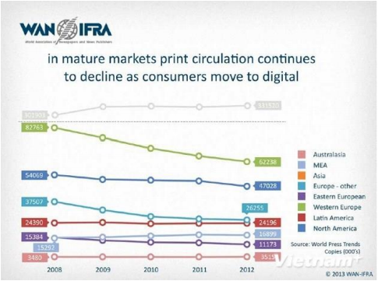

Figure 1-1 the graph show the number of print almost decreased in a lot of region, especially Western Europe and North America.1

--------------------------------------------------------------------------

1Source: *WAN-IFRA*

Nowadays, the trend of users gradually change from traditional newspapers to electrical news. Therefore, the effectives, profits of advertisement in traditional newspapers, magazines also reduce. According to the analysis of Chisholm Institute (Australia) on the press in Southeast Asia in Vietnam, the number of print edition per one thousand population is 60 sheets (in Southeast Asia, Singapore is the top position with 349 sheets). Indonesia is currently the largest in the region in terms of growing publishing rate with 29%, and Vietnam is equal to 0, Singapore is -6. Regarding profits from advertising on the print, Singapore leads with 489 USD per sheet, Vietnam is 15 USD, the lowest number in the region. Revenue from advertising in newspapers of Vietnam in five years ago has also tumbled 9%, this is the strongest rate of decrease in Southeast Asia.

**Advertising on TV**

Television is often called the "king" of conventional advertising media information, because most people spend more time watching television than in the day time for other media. Television combines the use images, color, sound and motion ... and the combination of these factors creates effective. Television has demonstrated admirable strength by continuously impacting on human behavior. Users buy the kind products and services that they have read and heard a lot on television.

This form of advertising is very expensive, only large enterprises have the ability to use forms of advertising. In addition, the design and building of footage advertising is not just a small challenge for many companies. Normally, TV viewers are familiar with the subtle advertising and therefore familiar with the expectation of watching the high quality ads. A sketchy advertising footage can seriously reduce the effectiveness of the message advertising, and even could create a bad image in the minds of customers.

Due to the amount of information consumers have recognized each day already overloaded, the opportunity of newspaper ads or TV has impressed enough to influence and persuade consumers use becomes very low. According to research by the Gallup Institute (largest market research corporation in America'): in 1965, just run a television ad 3 times in 3 consecutive days during peak hours on a national television channel, they can achieve the level of brand recognition by housewives group was 90%. In 2002, the ad runs needed to achieve 90% identify as 137 times in peak hours. The effectiveness of media channels has declined badly, while that ads costs rose so high that hardly acceptable.

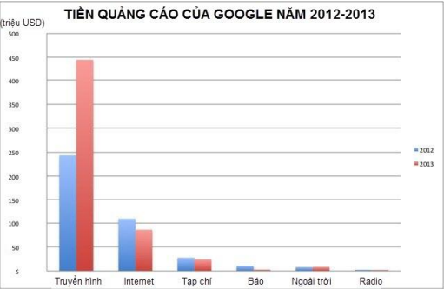

**Figure 1-2 Google ad prices. 1**

**Advertising on the Internet and Mobile**

Today, in the era of information technology break out, internet is an advertising method that are more and more preferred. By the internet, we can pass lots of message content, and there is an interaction with the recipient information. When customers are looking for information and services, besides the specialized pages looking like google.com, yahoo.com, bing.com ... there are a lot of specialized sites ads, classifieds, directories... that are accesed by many people for looking information. However apart from the specialized advertising pages in the most main sites, the remaining web is often not achieved high advertising effectiveness. These ads menu popup or rudimentary advertisement pages always annoy users, they always suspect that these ads can be links with computer viruses.

--------------------------------------------------------------------------

1Source: http://cafebiz.vn/quang-cao-thuong-hieu/chart-google-chi-bao-nhieu-tien-cho-quang-cao-ky-thuat  
so-2014042817041719013ca110.chn

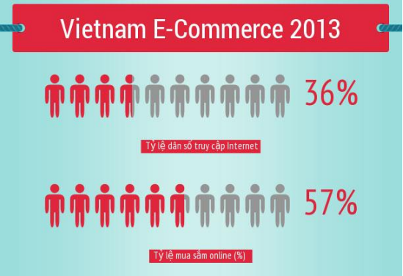

**Figure 1-3 Percentage of online shopping. 1**

In addition, the explosion of mobile devices also contributes to the advertising via the Internet more effectively. Information is passed to the hands of people using a quick and convenient way; with a mobile device with a network connection; we now have a huge repository of information. Advertising on mobile devices; beyond user access to the website to see the ads on the device's web browser, there are two other methods: advertise through SMS (messages on the phone) and via other applications.

Advertising via SMS usually from the one central telephone to the large number of other mobile phone to advertise. Users are mostly uncomfortable and always skip this ad messages.

Advertising via the app is one of the advertising way that give back the largest revenue. By this way, ads are popped up in the application of the mobile device or even outside the main screen of the device. But advertising via SMS or through other applications nor draw users because of the lack amount of information transmitted to the user.

Today, the development trend of advertising industry is aimed at making the reduction costs, increasing efficiency. The developers are switching from ads marketing information through television, newspapers, radio to the Internet and

--------------------------------------------------------------------------

1Source: According to the e-commerce and Information Technology department

mobile devices, because they target potential user groups, managing the statistic about level of interest, tastes of the users to contribute improving the effectiveness of ads. Internet advertising solves most of the restrictive than the traditional advertising, reducing costs; however, the method itself also has **limitations that conveys the information to the desirable user group encountering many difficulties** and users also do not **tend to pay attention on this ad information** (users often ignore, disable ad statements, and regard it as spam ...).

### 1.1.2. *Forms of promotion*

Besides advertising, communication, marketing managers also launched the promotional activities to attract, entice users to purchase products them. Promotions can be divided into 3 categories according to different objectives:

**Market survey promotions**

The category of promotion helps companies to operate the economic development strategy for a new type of item. By this method, they usually give the trial products, bundled with other products. For example, buying a bottle of shampoo attached a new kind of shower gel bottle. They even organized a market research campaigns, workshops, forums for consultation feedback and tastes of the user. There are currently many companies involved doing market surveys, they launch promotional items, coupons that are incentive for users. Their strategy that users give them the information, opinions, feedback on the type of product being studied. Then the opinion survey is sold to the production company.

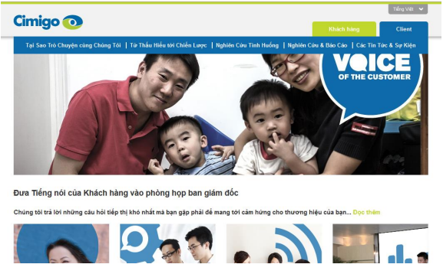

**Figure 1-4 Cimigo is one of the big company in researching market.**

**Enhance sales promotions**

This is the most common promotion, company discounts or donates accompanying product even give away their products. More than ever, price is the key element in marketing and it makes customers buying or avoiding product. A study of Cahners Advertising Research Report shows that 98.7% of customers affected by the price when they buy a certain product.

The establishment of the product requires very complex calculations and futuristic science. Most studies show that products with prices ending in odd numbers achieved retail sales higher products with prices ending in even numbers. About 80% of the products prices end in 9 or 5.

Jo Marney, a consultant of advertising / media in Toronto says that: "Pricing is a complex science and it is varied by product and market. A lot of basic marketing books emphasize that prices ending with odd numbers (e.g. 1, 3, 5, 7, 9), or near a certain round number (e.g. 99, 98) increase the sensitivity customer. In 1969, Lawrence Friedman (author of Psychological Pricing in the Food Industry) indicated that certain prices have an impact on the mind of shoppers come from a long-standing practice, because he found the prices ending with number "9" or "5" occupy nearly 80% of retail food prices. Nearly 50% of discount promotion is a multiple of 5, but the even number sale off are more dominant. [2]

**Branding promotions**

This categogy of advertising is not intended for a specific product, it is applied to a company brand. To perform this form of promotion, companies often create a compelling and catchy logo, a piece of music or a slogan associated with the company's image; and try to put the images, sentences to the community (through television, newspapers, social activities...). Besides, issuing membership cards, loyalty cards is one way that helps building the image in the eyes of users. By the guest card, companies entices huge amounts of potential, loyal customers. Customers return to use company products several times to get the priorities of the company.

Saving stamps (Saving stamps) is one of the programs to create first loyal guest. Sperry & Hutchinson introduced the Green Stamps introduced S & H - S & H Green Stamps - in Jackson, Mississippi in 1896 with the aim of simply to reward loyal customer. General Mills introduced Betty Cocker’s scoring bonus in 1920. In 1950, the tobacco manufacturing company started to celebrate the loyalty program by a coupon enclosed in the pack.

Loyal customers program began thriving in the 1980s. The airlines was the first companies to recognize the potential of this promotion type.

Customer card program was created in the mid-1980s by a lot of series of major hotels including Marriott, Holiday Inn, Radisson and Hyatt. A study of Radisson shows 70% of visitors surveyed are affected by promotion.

Today, it is calculated that 60% of Canadians having guest card loyalty, while nearly 70% of American shoppers have participated at least a loyalty program. The loyalty program is based on a fundamental argument that 80% of total sales come from 20% of total customers, regardless of what program is. A company can ensure reaching finance target if attracts 20% of customers.

The loyalty programs as Air Miles, Optimum and Aero plane in Canada not only help push revenue, but also help to companies better understand their customers. Zellers has maintained its loyalty program for 15 years. Club Z has nearly 10 million members, of which 7.6 million members regularly buy products each month. [2]

### 1.1.3. *Augmented reality, potential applications*

Augmented Reality (AR – Augmented Reality) is a variant of the Virtual Environments (VE - Virtual Environments), or normally known as virtual reality. VE is the technology takes the user into a synthetic environment. While using this technology, users cannot see other around things in the real world. In contrast, AR allows users to see the real world, with the Virtual World; objects are overlapped or combined with the real world. Thus, AR supplements the real world rather than completely replace. In the best case, everything appears for the reason that users see virtual and real objects exsiting in the same space, similar to the effect achieved in “Who Framed Roger Rabbit?” Figure 1-5 shows an example of how this can yet. This shows a real desk near a real phone, beside is a virtual lamp and a chair. Note that the object is a combination of 3-D, Virtual lamp and two chairs are the inclusion of the actual table. AR can be considered as the "combination" of VE (completely virtual) and Telepresence (completely true) [3]



**Figure 1-5 Picture of the movie "Who Framed Roger Rabbit?"**

Augmented reality is one of the potential development in the future. More and more organizations and businesses invest in research AR; notably Google is the giant in the village of technology at the moment. Project "Google Glass "Figure 1-6 is the realization of the ambition of dominating AR technology of this “search” giant. Style, functionality and efficiency of this smart glasses still needs to be verified; but need to confirm that Google and Google Glass possesses special advantage that no other company in the world can compare are: Google Search.

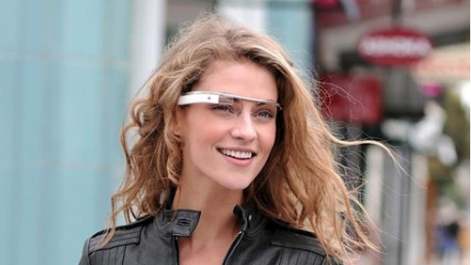

**Figure 1-6 Google Glass - the future of AR**

By the search system, Google controls the entire flow of information in online world. The role of Google in the Internet is identical to the role of a coach when you travel in the area being completely new. Information are almost in everywhere but what you see, know, or feel which is fully dependent or heavy dependent on what the tour guide just for you.

The launch of Google Glass can fully take search and supply information technology to a new level - temporarily dubbed the "interactive search" – ​​when users can completely search without any further action of the arms, all are absolutely conducted due to voice recognition engine. Combined with the huge amount of information controlled by Google, this can see that Glass is ready to stir technology world in the near future. [4]

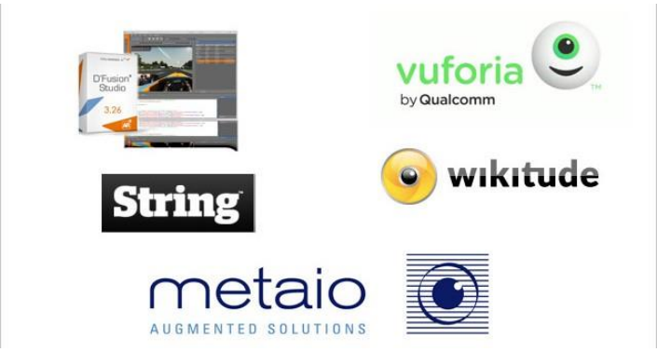

**Figure 1-7 Top 5 Augmented Reality SDK's.1**

AR can bring the best unprecedented user experience. From the provements, it can be judged that the development potential of AR in the future is very bright. However, there exists a number of ideas indicating AR is finally just a flashy marketing of technology manufacturers. This opinion is not correct, for AR applications at the moment do not have high realistic features, and are not apply on large range. Therefore, to make AR become future technology, manufacturers need to focus on resources in both sides: content and hardware.

In terms of content provision, AR technology needs to focus on the educational or entertaining aspects. We can confirm that success or failure of AR is determined by two trends: image and sound recognition. Feature “image recognition” allows users to learn the depth of product and motivates innovation. Feature “sound recognition” opens up new opportunity for traiditional communication tools to interact with consumers. [4]

--------------------------------------------------------------------------

1Source: http://augmentedrealitynews.org/ar-sdk/top-5-augmented-reality-sdks/

## 1.2 The motivation to do the topic

From the assessment of the limitations of traditional advertising methods and the rapid development of AR technology mentioned above; team has proposed the better solution for the deployment of the advertising program. It is the use example internet, mobile devices and **application of augmented reality in order to help the advertisement, disseminate information efficiently and more enjoyable**.

In fact, there were some projects applying AR technology in advertising but they mainly just stop at the trial, study or simply polish names for famous brands through fun and fresh AR products, they do not really aim at finding effective advertising.

To make the media programs, promotional information become no longer boring, monotonous with static information, the augmented reality helps users having more expanded information, fascinating, and multi-dimensional, real-time updates. It also helps users having interactive feedback. Advertisers have the exact statistic numbers to make the program more effective. That is the purpose of the construction of the **applications of augmented reality systems in advertising industry**.

## 1.3. Objectives of topic

Because the advertising section is a very broad field with the large number of products (electronic products, home appliances, industrial goods ....) so that team decide to build a demo system in particular business that is the field of advertising based on movie titles. Therefore, the interaction between real users with products revolve around the topic about selection and watching movies at the cinemas.

The objective of this research is to develop a system for managing integrated advertising campaigns on mobile devices with augmented reality technology; and construction of the augmented reality presenter module in the form of multimedia, social media information on mobile devices (Android platform) following the campaigns that have been already defined.

The system consists of two main modules:

* ***Management module* (Manager):** This is a website built on the ASP.NET platform. It allows managers to build advertising, promotion programs using augmented reality by the simple operations.

The main functions of the module are:

- Additional augmented resources in multi-media formats (image, sound audio, video ...), social-media (web links for reference, blog, forum ...) and interactive activities if there is (implementation the survey questions, like, share, and comment on products ...) any picture of the product.

- Develop advertising campaigns: promotion, gifts, sale off, offer the activities interacting with the user...

- Manage advertising campaigns: change the duration of the campaign, perform statistics by multiple criteria (people who have attended, time, age, gender of users).

- Show all the products and attached augmented resources for users (not necessarily managers) having a global view about the ongoing products and the campaigns.

- Provides API for creating interactive bridge between databases with mobile devices and the web.

* ***Presenter*** ***module* (*Presenter*):** built on the Android platform, the module allows users to scan an image which has been uploaded to the database and performances augmented objects. Some key functions of this module includes:

- Allows users to register, login account.

- Show ongoing programs, advertising campaigns, the new campaigns, and the campaigns which users have participated...

- Display of the tasks and interactive activities with users, promotion and benefits of users.

- Allows users to scan images of products to show augmented resources, information of products.

- Allows users to like, share, comment, and feedback about products.

- Show support, instruction for user to use interactive activities, complete the tasks, and get the rewards, benefits...

## 1.4. Content of topic

Thesis consists of 7 chapters:

**Chapter 1**: Overview of the potential of augmented reality and the limit points of content on planar document as well as the study about the status and practical application of augmented reality in the field of advertisement. From the following reasons, we motivate to implement the project and objectives of the topic.

**Chapter 2**: Jump start in the actual situation of the advertising industry. The statistics on the state of using mobile devices in recent years. Some points and concepts need to know about the augmented reality and application of this technology in mobile advertisement.

**Chapter 3**: Describe the general architecture, basic design of the system and explain the technology of back end in the system.

**Chapter 5**: The main objective of the Management Module is to help to support the enterprise customers for management advertising campaigns. Because the process of implementing this system, team cannot avoid internal problems about content and we raise these issues and approach methods (solution) which we applied. Moreover, the content of chapter introduce about processes as well as structure of Management Module.

**Chapter 6**: This chapter focuses on augmented reality of Vuforia: The architecture of the Vuforia application, Architecture of SDK, some features or supported functions. Furthermore, this chapter describes these issues and solution that helps team to solve the problems when we build the Presenter Module.

**Chapter 7**: Summary, present the achieved results and the development of dissertation.

Chapter 2

Advertising on mobile and augmented reality

*✍ Chapter 2 presents an overview of mobile devices, how the industrial advertisement on mobile has developed. Next is an overview of the augmented reality technology and its applications, usability on mobile devices for the purpose of advertisement.*

2.1. Mobile devices and advertising

2.1.1. *Mobile Devices*

Today, mobile devices are familiar to everyone – there are a lot of mobile devices everywhere in the world with different types, shapes, sizes, and categories – good enough to satisfy all class, age, gender, and region.

The development of the mobile device industry is growing faster. According to the Market research (2013):

* 91% of people on earth use at least one mobile phone.
* 56% of people have smart phones.
* 50% of phone users choose phone as primary device to access internet.
* 72% of users use tablets for transactions every week. [5]

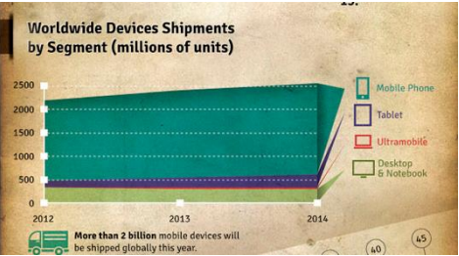

**(a) More than 2 billion devices sold in 2013**

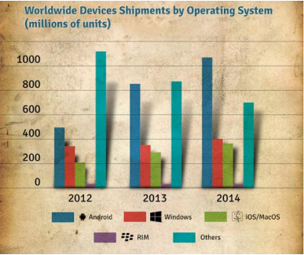

**(b) Numbers devices running mobile operating systems**

Figure 2-1 the number of mobile devices and mobile operating systems.

Not only had the development of the device, but the operating system used on the devices also the top priority standard of customers. Among them the most prominent operating systems are iOS (Apple), Android (Google), Blackberry OS (Blackberry), Windows Phone (Microsoft). Android has led with the number of devices using the operating system at more than 1 billion.

Today, the popularity of mobile devices depends on the price. Because equipment suppliers regularly produce the product quality with variety of designs and reasonable prices that attract many users. For each person, consultation and selection issue to review and buy themselves a tablet or a smart phone is very simple.

The number mentioned above help us somewhat to see the development of applications as games, graphics applications, utility programs, advertising ... on mobile devices has always been the preferred choice of software developers.

2.1.2. *Advertisement on mobile*

Advertisement is a basic form of marketing, the purpose of it is to attract the interest of users to business, product or service which supplier bring out. Along continuous development of economy, advertising plays a important and indispensable role.

Nowadays, people can find and see ads everywhere: from posters, banners, leaflets or video shown on television every day.

The consumer market has become very competitive with a new born brand. Despite of the product you are looking for or quantity of brands which are available are really interested, concern of each marketer normally is to promote their brand with a good image than their competitors.

Advertisement is to broadcast, communicate a message of the service or new product to public / consumers as the flow of information about a product or services from the seller to the buyer. However, advertisement does not end with the flow of information alone but also to go further, to influence and persuade public to make a desirable action such as buying products.

As report of eMarketer published in The Guardian, revenue of mobile platform advertisement overtakes revenues of advertisement in newspapers and magazines in print England with distances of up to several billion pounds in the next year.

Similarly, in 2016, the predicted revenue from mobile advertisement beyond revenue of advertisement on television with the expected number to 4.5 billion pounds (equivalent to about 7.7 billion USD). [6]

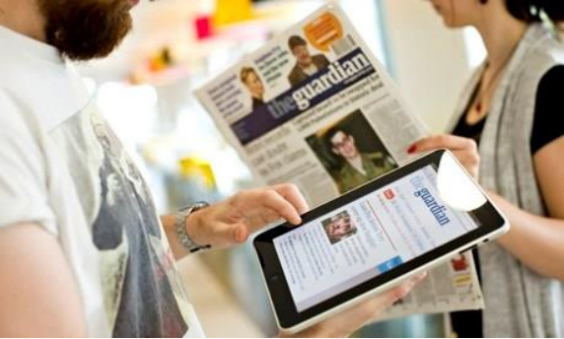

Figure 2-2 Season of mobile devices and

Advertising on mobile platforms is crowned. [6]

The Guardian references from eMarketer – the largest marketing agency, media and US market, said that revenue of advertisement on mobile platforms in 2014 in UK is estimated about 2.02 billion £ and has a current record pace: 96%.

According to experts, British print revenues and magazines in 2014 was approximately to 2.06 billion pounds. By the current gains, revenue on mobile advertisement overtakes printing industry soon.

This is considered as inevitable development trend of the era of mobile devices to the throne. EMarketer estimates that up to 2018, about half the British population owns each one iPad, Kindle, or a similar type of tablet.

In 2015, the mobile advertising market grows further 60% with expected revenue reaching approximately 3.2 billion pounds while advertisement on newspapers and magazines would only take 2.7 to 2.8 billion pounds.

This is a giant step. 4 years ago, the entire revenue of mobile advertising market in English is only evaluated about 83 million pounds, but so far, this number has increased nearly 3 times and there is no signs of stopping. Experts predict that in 2016, revenue of mobile advertisement remains at about 38% growth and get 4.46 billion pounds.

Meanwhile, revenue of television advertisement in equivalent time (2016) is only at about 3.8 billion pounds.

At the moment, the total market of digital advertising in the UK is estimated at about 7.25 billion pounds, is expected to increase 7.97 billion pounds in 2015 and hit 8.64 billion pounds in 2016.

In 2014, revenue of advertisement on mobile is just about 30% of the previous numbers, but by 2016, this ratio increases over 50%.

However, the advertising information to a client about the existing of a brand is not enough. Advertisement need focus to potential targets in such a way to create a positive impact on the clients and in the process, this creates brand recognition. Therefore, marketers often target in advertising campaign in the group for clients.

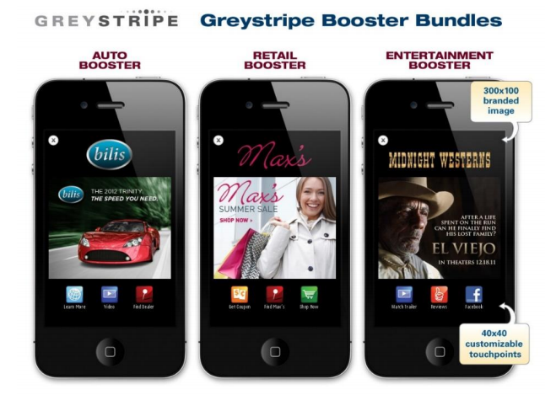

Figure 2-3 Advertisement on mobile

In additional, advertisement in the traditional ways now still has disadvantages points as:

* Users can not view many contents that they need. They can only look on a poster or on a leaflet.
* The information given to consumers is not dynamic: text, image (on leaflets, posters).
* Do not review the content which consumers are interested in when seeing ads on TV.
* Fees for advertisement on television, posters are very high.
* Failed to interact with content or company.
* Difficult to attract different classes that companies target.
* Difficult to perform statistical evaluation about the level of attention of customers using the product, see the ad. The compliment from users are not fully collected in exact way and this leads to the wrong orientation in business strategies.

2.2. Augmented reality

2.2.1. *Augmented reality*

Augmented reality is the image processing from the surrounding environment in real world to determine the object and provide augmented information for founded objects and equipment. The application is programmed, built by integration to handle information received through the camera on the mobile device. The camera of mobile devices recognize and analyze the founded object (probably shaped object, photo or text and usually a range of bar codes in black and white color) which help the programmers to determine ways to add augmented information (text, pictures photos, audio or video ...) for the object and display to the users by the following ways:

Determine position, angles of found objects (planar data) than the camera's devices to draw information on the right marked spatial 3-D position. Or draw the 3D object.

Show augmented information about objects on users’ devices and additional features that users can interact with service providers.

The common point of the two methods is that the user can interact directly to augmented information. Augmented information are met in real time. AR only beginning to meet the needs of military and industry. When applying somewhere outside laboratory, AR become popular demand in social life.

Augmented reality appeared soon in the 1950s:

* 1957-1962: Morton Heilig - a cinematographer has created and been patented the invention of a device called Sensorama simulator providing pictures, sound, vibration, and scent.
* 1975: Myron Krueger created VideoPlace that allows users to interact with virtual objects for the first time in the world.

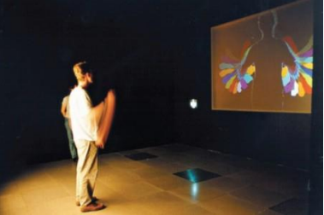

Figure 2-4 Myron Krueger interacted with video place.

* 1980: Steve Mann was the one who created the first wearable computer in the world - is a vision system computer with text and graphics overlaid on the actual image.

The system was further developed until 1990, the term "augmented reality" is officially used and who coined the term is a researcher of Boeing - Tom Caudell. Then, this technology is developing rapidly.

One typical application may include is the use of CAD (Computer Aided Design) to simulate the assembly of an aircraft, military, health care ... This technology is also used widely in the fields of advertisement, marketing.

In fact, this technology has proven to be very useful in today's life. When tied to place determination technology, some applications are built to help display to users of a grocery store, clothing store or shopping to identify traffic stations, the nearest visited destination...

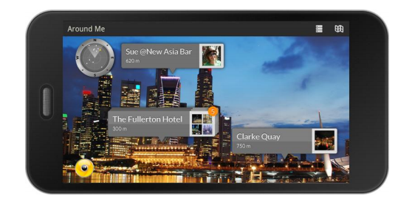

(A) The application Wikitude allows to search recent services around you.1 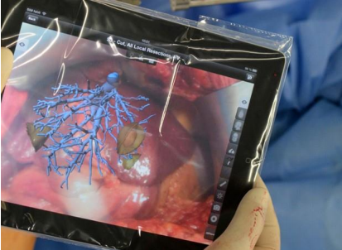

(B) The liver surgeon technological devices using AR.2

Figure 2-5 the application uses the reality enhancement.

In the medical field, this technology can give the surgeon the information which cannot be seen as: heart rate, blood pressure, the anatomical patient ... AR can be used to help doctors to look inside in a patient’s body by providing an X-ray image.

The most recent is the born of Google Glass devices announced by Google in 2013 with the notable feature:

* Navigation system on this device informs you exactly what you need to turn in street corner, displays a map surrounding area via Google Maps.
* Foreign language translation directly on the screen of Google Glass.
* Search for information of the products you see in front of your eyes then displays directly onto the device.3

--------------------------------------------------------------------------

1Source: http://www.wikitude.com/app/how-to-use-wikitude/  
2Source: http://www.engadget.com/2013/08/22/fraunhofer-ipad-app-guides-liver-surgery/  
3Source: http://timesofindia.indiatimes.com/tech/slideshow/googleglass/Translate/itslideshow/18609226.cms

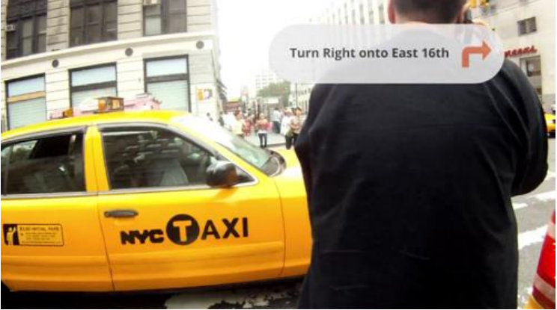

Figure 2-6 Google Glass path guide.

2.2.2. *Augmented reality applications in advertising*

Based on the providing information, the goal is to attract a large number of customers and minimize the current advertising restrictions as we can. The application of *augmented reality* technologies in advertising is one of modern options and highly appreciated.

Today, there are many enterprise applying this technology on the mobile devices to promote his company's products to the public. This provides a pretty good solution for bringing their image or helping the user to interact directly to the products.

From May 1/2011, REAL Group (France) real estate company provides free REAL me application on iPhone, iPad and Android phones that help users to buy or rent houses, apartments at the desired location. When the lens phone towards certain buildings belonging REAL Group, users can REAL me get information about the apartments they are targeting, superimposed images obtained by tube glasses.

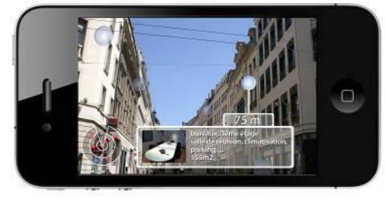 (a) REALme app supplies information about department in France).1

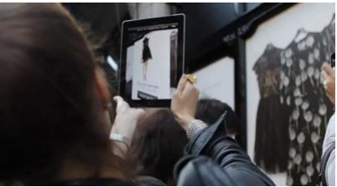

(b) The user views Apartments of Net-A-Porter.

Figure 2-7 the application software enhanced reality in advertising.

9/2011, Net-A-Porter company decorated the entire store's clothing Alone in the big city like Paris, New York, London, Munich Photos by images in the collection of Karl Lagerfeld. Passersby are instructed how to download an application of company here. Users simply open the application and scanned image of the product through the device's camera. Immediately, the message about product information is displayed to the user view: specs, video demo clothing test samples, prices ... besides that users can select to how purchases and how to do online payment on the application.

Or as an advertising campaign of Volkswagen company in Canada. In 9/2011, car producers have urged people to download application VWJuicedUp to device. When the application has been installed, users simply use their mobile devices installed applications at the marked point on advertising board given by car producers. At this time, on the device - viewers are treated to a performance of the car reflected on advertising board that users towards. The car runs from advertising board and performances. [7]

--------------------------------------------------------------------------

1Source: <http://echip.com.vn/thuc-tai-tang-cuong-a20130314160058393-c1107.html>

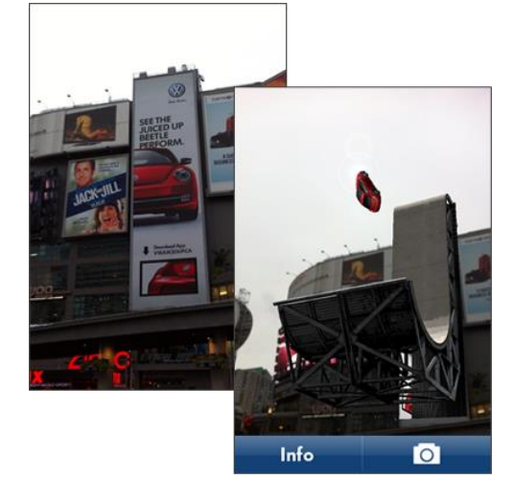

Figure 2-8 Performance on the device of the Volkswagen car.1

How to apply *augmented reality* technology to advertisement to bring benefits for business: the interests of users, low cost, high popularity, convenience (direct purchases)...

It is sure to conclude that the number of people using mobile devices is increasing. By this reason, the common level using applications of third parties is proportional. When the application is downloaded, the scan an object, image, or text which provides plenty of needed information to them, promote their curiosity. As long as content augmented information of provider are attractiveness, interesting, creative and good interaction and meanwhile the increase number of clients using *augmented reality* applications are great turning point for the advertisement industry and services.

--------------------------------------------------------------------------

1Source: <http://randymatheson.com/?p=668>

2.3. Conclusion

The content that team presents in Chapter 2 shows the overview status of the operating environment of the mobile devices, the development of them. The continuous growth and importance of Advertising for the economy at the moment are clearly stated. Finally, the important points of the program is the technology that team focus on is *augmented reality*: a few things about this technology to show how it works, the interest in technology that companies, enterprises research to use it for promoting their products.

# Chapter 3

**System design and architecture**

*✍ Content of chapter 3 presents general architecture of the system and basic design of each components.*

## 3.1. Solution architecture

**3.1.1. *2-tiers architecture and 3-tiers architecture***

***3.1.1.1. Limitation of 2-tiers architecture***

2-tiers architecture is typical client-server system that server runs a DBMS for storing and retrieving physical data and optionally business execution (store procedure); and client is fat client. The client is responsible for connecting to server to exchange data, applying business rules, managing transactions, presenting data to the users and collecting input from users, resolving concurrent access problem,…

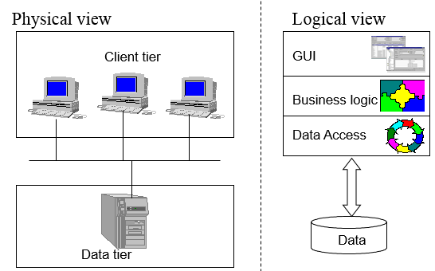

**Figure 3.1 Physical and logical view of 2-tiers architecture**

As the figure above, in 2-tiers architecture, client and server interact directly to each other. This has the some advantages as well as disadvantages points.

**Advantages**

Application can be easily to develop. Database server and business logic is physically closed, which make higher performance.

**Disadvantages**

The 2-tier model is lack of scalability because it only support a limited number of users. Moreover, server must process a large request centrally.

***3.1.1.2. Advantages and disadvantages of 3-tiers architecture***

To overcome with the disadvantages of 2-tiers architecture, the model of 3-tiers architecture are born. Data tier are the same; however, it has an application server (business tier) that implements and applies all business rules. Client tier are the same, but it does not connect to Data tier directly. Instead of doing this, client send request to business tier. Sometimes, the server load balance are available for process a large number of requests.

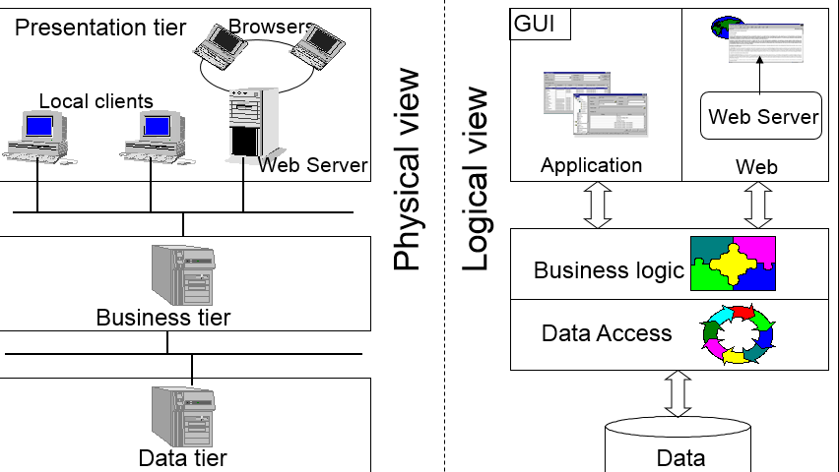

**Figure 3.2 Physical and logical view of 3-tiers architecture**

The **advantages** of this model is the ability to reuse code, effective running application. Moreover, the scalability (load balancing, connection pooling…) is also the most important factor that we must concern. For the view of developers, the model allows to separate clearly modules. This makes us easily to maintain and upgrade.

However, 3-tiers architecture still has some **disadvantages** such as: more infrastructure work and complex architecture. It takes more time and budget for implementation.

**3.1.2. *Application of 3-tiers architecture in the system***

***3.1.2.1. Why we use 3-tiers architecture***

***3.1.2.2. Basic design structure***

Based on 3-tiers architecture, we design the system as the Figure 3.3 below. In each tiers (physical view)), there are one or many layers to perform suitable functions.

**Common**

**WEB & APPLICATION**

**PRESENTATION TIER**

**SERVICES**

**DAO**

**BUSINESS TIER**



**DATA TIER**

**Figure 3.3 Application of 3-tiers architecture in the system**

The **data tier** contains 1.mdf file (extension of MS SQL Server database file) and its backup files, log files.

The **business tier** contains 2 layers:

* Data access layers (DAO) plays only 1 primary roles: access directly to database (supported by ORM framework – NHibernate) to perform CRUD operations.
* Service layers provides interfaces to clients meaning web application (manager module) and mobile application (presenter module) for accessing to data in defined ways that are defined. All business logic, exception handling, and concurrent update handling are processed in the layers and serializable to other layers.

The **presentation tier** is the diverse definitions. In generic term, it contains 2 primary terms: web application (manager module) and mobile application (presenter module). To explain exactly the meaning of presentation tier, we set it comprising all mobiles devices which use the presenter module application and all devices that use the manager module web.

Common section defines a lot of classes, helpers, extension methods that are used in many different ways. For examples:

* Dto: The NHibernate mapping (ORM definition) classes that map with tables in database design.
* JsonHelpers: A class contains methods for parsing classes to JSON and vice versa as well as parsing XML to JSON and vice versa.
* ExtensionMethod: Brings the Append() method of StringBuilder to String (C#)
* Services interface: Interface for clients to call services API.

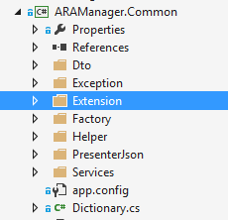

**Figure 3.4 Common module in solution**

## 3.2. Services layer

### 3.2.1. *WCF – RESTful*

#### *3.2.1.1. Problem*

Develop web service system to help query data operation, information are concerned from both Modules: Manager and Presenter in an efficient way.

#### *3.2.1.2. Solution*

Team proposes to build a system providing Web Service API supplying functions to query based on RESTful architecture.

***What is RESTful?***

REST is given to apply a constructive way and simple web service perform operation of main complex concept of traditional Web Services.

REST stands for Representational State Transfer - in the sense of allowing users to access resources - resource (is data before and after handling or functionalities of the applications) – Web services application through URL.

Mechanisms between server and client is point to point.

The data is transmitted directly over HTTP and is accessed via HTTP under MIME format without SOAP format - reduce complexity - for simplicity, we shall consider data and functions as parameters or data transmission attached in HTTP

Allowing data manipulation under 4/7 method defined in HTTP as GET, POST, PUT, DELETE to clearly specify how to manipulate data on the server, what are accessed, what are edited, which are displayed and hidden ...

Requests when using REST:

* Client and Server: Client and Server must talk using the same interface and protocol
* Use the layers architecture and do not store status after the process is responded
* Cache Memory: the return value is stored in the client
* Code on Demand: clients obtain data in the returned value after processes in servers are completed.
* Uniform Interface: each client resource is accessed through unique address and use the defined method.

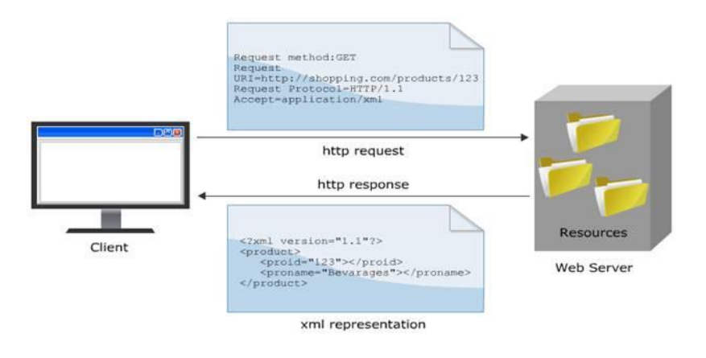

**Figure 3.1 The mechanism of RESTful.1**

***Why choose RESTful?***

Nowadays, in the world, there are two kinds of common architectures used to build a Web Service system are: RESTful and SOAP. Here would be the comparison between two buildings on.

By the parameters Table 3-1 below, we can perceive some benefit in using RESTful are:

* Do not depend on any intermediary system - as SOAP and WSDL do.
* The design using RESTful transmits data via protocol HTTP allows internal applications to use in an easy and powerful way: Asynchronous JavaScript + XML / JSON (Ajax).
* The strong combination of AJAX and RESTful also makes more developers to learn and use.

--------------------------------------------------------------------------

1Source: http://kieutrongkhanh.net/index.php/java-web-service-x/79-gii-thiu-v-restful-web-services

* Get the data stored on the server and analyze the returned data

### 3.2.2. *Ninject*

To reduce the dependency on hard code between classes by removing the dependency in running time. We have to build a design model called inversion of control.

## 3.3. Data access layer

### 3.3.1. *ORM Mapping – NHibernate framework*

#### *3.3.1.1. Problem*

Build an ORM to map object model to database model for easily working.

#### *3.3.1.2. Solution*

Object-oriented and relational database may be cumbersome. NHibernate is an object/relational mapping tool for .NET environments. Object/relational mapping (ORM) refers to the technique of mapping a data representation from an object model to a relational data model.

NHibernate also help developers in:

* Data query and retrieval facilities in compare with manual data handling in SQL and ADO.NET
* Useful with object-oriented domain models and business logic
* Remove or encapsulate vendor-specific SQL code
* Help with the common task of result set translation from a tabular representation to a graph of objects.

# Chapter 4

**Some problems and technology solution for develop**

**Management module**

*✍ Content of chapter 4 presents some problems encountered in building management module, interface issues, and expressing information. In Chapter 4, team also presents the ASP.NET technology to this module.*

## 4.1. The objectives of the management module

The module contains 2 types of users:

_ Admin: the module supports admin to manage customers and companies account as well as view statistics.

_ Company’ manager: Team builds the module to support in the design augmented information to perform show in presenter module. This module allows marketing managers to build advertising campaign with augmented information; do statistics, manage campaigns and users that have joined the campaign.

## 4.2. Processes of Admin’ functions

### 4.2.1. *Create, View, Edit, and Delete customer*

After login to system, Admin users can select section “Customer” to go to Customer manager page.

At this page, admin can search customer by UserName,… Then the search result containing list of suitable customers are returned. Admin are able to edit, delete or update information of any customers by simple clicking on his or her id, the action navigates to edit page.

There is another functions is to create new customer account for Admin role. The function is built to face with the case that company directly to Admin instead of sending information of company through email.

### 4.2.2. *Create, View, Edit, and Delete company account*

After Admin receive information of company through email or direct request, he or she go to “Company” management page to company account.

Admin can also search company by UserName to view and/or edit information. He or she can delete the company account in system if there is any suitable reason such as: company leaves the system, company violates regulation, and company does not work at the moment…

### 4.2.3. *View statistic*

The statistic function let Admin follow the rate of customers by male and female, age.

From the result, Admin recognize the development of system to make suitable business plan.

Figure vào

## 4.3. Processes of Company’ manager’ function

### 4.3.1. *Create, View, Edit, and Delete campaign*

Adding a new campaign displayed on the interface of web browsers by 3 following steps:

* Step 1: Choose category for a new campaign: check in, tour and theater. Regarding this category of campaign, if the system is applied and implemented widely, we will have more extensive variety of different campaigns, not only encapsulated in 1 or 2 categories as test systems.
* Step 2: Provide information about the campaign. The required information of a campaign will be added here: campaign name, start date and time, end date and time, a brief description about the campaign. The number of tasks needed to be complete.
* Step 3: Provide information of missions. At this stage, the number of missions provided in Step 2 will be described clearly. For each mission, users need to upload pictures for using in each respective task. At this step, website builds and supplies a particular site for users to upload pictures. Required information of images that will be posted are Link and Image Name (no space).
* After the posting step completes, the image will be uploaded to the Cloud Server and analyzed. The process is long or fast depending on the size and complexity of color in photos. The returned result will be one string. Users simply paste the recent received string in the box “Symbol” in Step 3. The series of characters is also the primary key of the task.
* In addition, since this is a campaign about the movie so the needed information providing for tasks are about movies information: movie name, actors, director, manufacturing year ...

Since the image information processing on Cloud Server is invariant, no fixed time depending on image quality and complexity of images, to make sure about the time required for the program may start running, users should wait after 2-3 hours.

After completing 3 above steps and approximate 2-3 hours waiting for processing images on the Cloud Server, campaign design is complete and it can start working.

### 4.3.2. *View statistics*

View statistics of campaign

## 4.4. Solution

### 4.3.1. *Architecture*

Web call client services factory -> services -> DAO

### 4.3.2. *Technologies*

4.3.2.1. Show Map

4.3.2.2. Show statistics charts

4.3.2.3. Bootstrap

Bootstrap is a collection of CSS and JavaScript that strongly supports design layout of a web-based interface. Bootstrap supports many Web browsers on computers as well as mobile devices. Today, there are millions of websites being designed thanks to this framework. By more than 200 icons and hundreds of professional effects, Bootstrap can help us to quickly have the most delicate site layout in a simple way.

## 4.5. Result

Manager module has a nice user interface, professional and easy to use. The website is currently deployed on computing technology cloud (cloud services - CS) of xyz- one of the best free powerful CS suppliers for websites built with ASP.net. Here are some pictures of the module.

## 4.6. Conclusion

Manager module focuses on designing eye-catching interface, simple to use, providing marketing managers an easy working environment. It does not require high information technology knowledge to use the management website; users easily create advertising campaigns using augmented reality.

By using ASP.NET architecture, the website is designed in the way that is very compact lightweight, easy to grow in the future. The user interface of the site can be customized quickly, suitable for trend and demand of users without attention about the process of logic in the system due to the support of model.

# REFERENCES

[1] NguyenMauTam, "Quảng Cáo là gì ?," Vnecon.vn, 8 4 2008. [Online]. Available: <http://www.vnecon.vn/threads/quang-cao-la-gi.1122/>.

[2] "Tối ưu hóa chiến dịch khuyến mại của doanh nghiệp," Báo doanh nhân sài  
gòn điện tử, 02 08 2010. [Online].

[3] R. T. Azuma, "A Survey of Augmented Reality," Malibu, 1995.

[4] genk, "Augmented Reality – Chân trời mới của thế giới công nghệ không còn quá xa vời," genk.vn, 30 june 2012. [Online]. Available: <http://genk.vn/pc-dochoi-so/augmented-reality-chan-troi-moi-cua-the-gioi-cong-nghe-khong-conqua-xa-voi-2012062912589808.chn>.

[5] AF-STUDIO, Super Monitoring, "Infographic: 2013 Mobile Growth Statistic," Digitalbuzzblog, 1 10 2013. [Online]. Available: <http://www.digitalbuzzblog.com/infographic-2013-mobile-growth-statistics/>.

[6] Infonet, "Thời của quảng cáo trên thiết bị di động lên ngôi," Vietnamnet, 2 7 2014. [Online]. Available: <http://vietnamnet.vn/vn/cong-nghe-thong-tin-vienthong/183865/thoi-cua-quang-cao-tren-thiet-bi-di-dong-len-ngoi.html>.

[7] B. Insider, "11 Amazing Augmented Reality Ads," Business Insider, 28 1 2012. [Online]. Available: http://www.businessinsider.com/11-amazingaugmented-reality-ads-2012-1#net-a-porter-makes-storefronts-interactive-1.